SUPPLEMENTAL TEACHING MATERIAL
The Trial of Mary Mallon
An Appeal to the New York Supreme Court
(Worth 30 points)

Roles (all are gender-neutral). Some of these were created for this class activity.
Note: Everyone is expected to speak approximately 5 minutes in this activity.

Justice Geigerich: The New York Supreme Court judge that oversaw the trial – Dr. Foss
Mary Mallon: Molly, An American Girl Doll

Defending Mary Mallon
G. F. O’Neill: Mallon’s attorney, arguing that Mallon is being held without a charge or due process. Will do the opening argument.
C.G. Johnson: O’Neill’s legal partner. Has a keen eye for detail and a profound understanding of the New York court system. Will question/cross-examine the witnesses.
H. Bellacourt: A law clerk for O’Neill. A novice in the courtroom, but eager to learn with a strong work ethic. Will do the closing argument.

Representing the New York Health Department
B.C. Douglas: lead attorney, defending the Health Department’s actions in detaining Mallon against her will. Has previous experience arguing for compulsory vaccination and other public health-type cases that set a precedent for this particular case. Will do the opening argument.
R.J. Puffleton: The law partner of Douglas. Stone-faced and stern, Puffleton is rigid to a fault. Will question/cross-examine the witness.
X.R. McBeezel: A law clerk in the firm of Douglas & Puffleton. On a second career path after several years studying biology in a newly-formed research lab. Will do the closing argument.

Witnesses (will do their 5 minutes in the form of answering questions. Be prepared)
Dr. J. Baker: You are being subpoenaed to testify for your role in helping to track down Mallon and bringing her to the hospital. You are the public health expert.
Sanitary Engineer Soper: “Sanitary engineer” who first determined why people got sick at Oyster Bay. Made his career out of hunting down Mallon.
J. Coleman Drayton: One of Mallon’s former employers. Six of 11 people in the household became sick when typhoid when Mallon cooked there.

Jury Members (will do their speaking time by each asking a question, conferring, and reporting the verdict).
B.B. Bakersfield: Middle-aged with four children. Spends summers in Oyster Bay but is unfamiliar with the Drayton household.
D.D. Partortise: Late 20s medical doctor at a New York Hospital
P.L. Zorba: A poor immigrant who works at the Westfield Welch grape juice factory since it was built in 1897. You have worked your way up from the crushing room to shift supervisor of the bottling team. Your position demonstrates your leadership, while your purple-stained hands mark your gumption.

The Press
You will give three brief statements: before the trial, on a break during the trial, and after the trial concludes. How you choose to cover this case will permanently shape and construct the image of the Mary Mallon case for more than a century.
How do you cover the case? Who do you interview and quote? What is your framing? Your name for Mary?
I.G. Radcliffe: Reporter for the New York American. You go into the case believing that Mallon is a vessel of disease and you are determined to tell that side of the story.
E.W. Feinerstein: Reporter for the Golden Sphere, a new publication committed to covering and advocating for immigrant communities.
R.P. Morose: Reporter for the Washington Journal, dedicated to the new emerging form of journalism—the objective model (in other words, dedicated to getting multiple perspectives).

Process
Before class meets
- Indicate your role preferences. All roles are gender neutral and have approximately the same amount of speaking time.
- Read the “Typhoid Mary” chapter of the textbook.
- Look over the materials posted for this week’s module. Conduct research on your own for the key figures in this case.
- Take the reading response.
- Prepare a bulleted list of notes that detail the following:
  - What you think your position would be (note: many of these names are fictious so you are speculating on the position based on your research of the case)?
  - Background and key arguments for your position or positions. If you are on the jury or part of the press team, create an abbreviated list for both positions, plus at least 2 questions you would like to ask.
  - What your opponent’s key arguments and strengths may be. Witnesses should briefly outline the positions of both Mallon’s and the NY Health Department’s attorneys.
- Arrive to class early – prepared to carry out the trial. Bring your notes.

At the Trial
- The press will each ask one question of a person of their choosing before the trial starts.
- Dr. Foss will initiate the trial, beginning with the opening statements from the attorneys of Mary Mallon and the New York Health Department (5 minutes each max).
- Attorneys will call and question their witnesses. Witnesses should be prepared to speculate what their positions would be based on the chapter, your materials, and your research.
- Both teams will give closing statements (done by other members of the legal team), up to 5 minutes each.
- The jury will confer and may ask up to 3 additional questions.
- The jury tells the judge the verdict.
- The judge announces the verdict.
- The press will ask 1-3 questions, confer, and then announce how the story will be framed in their individual papers.

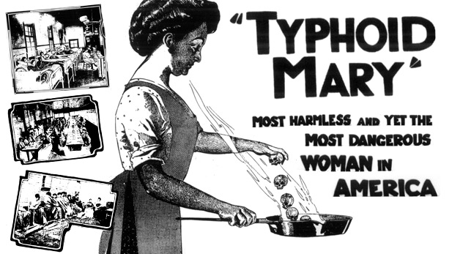
June 20, 1909. The New York American.

